# PROJECT 2 PROPOSAL

## Title: Europe Migration Story since 2000

## Team Members:

Anna

Arunapriya Naripeddy

Sophie

Vedant Vashishth

## Description

Our project is the story around Europe migration since 2000. The focus will be around the refugee influx since 2000 into Europe and the story will be present through a set of visualizations based on the data available from United Nations.

## Sources for Data Collection:

Below are the current list of sources identified for data collection.

1. UNData: http://data.un.org/Data.aspx?d=UNHCR&f=indID%3AType-Ref
2. UNHCR: <http://popstats.unhcr.org/en/persons_of_concern>
3. Eurostat: <http://appsso.eurostat.ec.europa.eu/nui/show.do?query=BOOKMARK_DS-055296_QID_-4795F7E9_UID_-3F171EB0&layout=TIME,C,X,0;CITIZEN,L,Y,0;GEO,L,Y,1;SEX,L,Z,0;AGE,L,Z,1;ASYL_APP,L,Z,2;UNIT,L,Z,3;INDICATORS,C,Z,4;&zSelection=DS-055296ASYL_APP,ASY_APP;DS-055296UNIT,PER;DS-055296INDICATORS,OBS_FLAG;DS-055296AGE,TOTAL;DS-055296SEX,T;&rankName1=UNIT_1_2_-1_2&rankName2=AGE_1_2_-1_2&rankName3=INDICATORS_1_2_-1_2&rankName4=ASYL-APP_1_2_-1_2&rankName5=SEX_1_2_-1_2&rankName6=TIME_1_0_0_0&rankName7=CITIZEN_1_2_0_1&rankName8=GEO_1_2_1_1&sortC=ASC_-1_FIRST&rStp=&cStp=&rDCh=&cDCh=&rDM=true&cDM=true&footnes=false&empty=false&wai=false&time_mode=NONE&time_most_recent=false&lang=EN&cfo=%23%23%23%2C%23%23%23.%23%23%23>

## Story via Data Visualization

Below are few examples of visualizations that we are using as the baseline for the project story telling. We are looking at capturing the story with the following example visualizations.

1. **Asylum Seekers per country in EU**

Link - <http://www.europarl.europa.eu/external/html/welcomingeurope/default_en.htm>

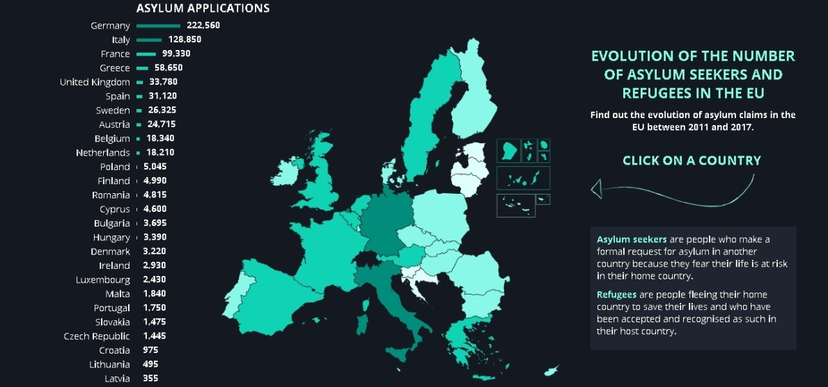

1. **Refugee Influx Flow (From->To)**

Link: <http://openmigration.org/en/dashboard/>

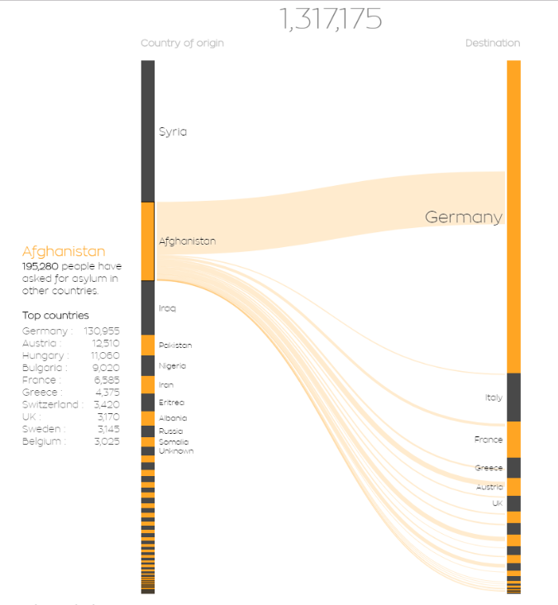

Link: <https://www.lucify.com/the-flow-towards-europe/>

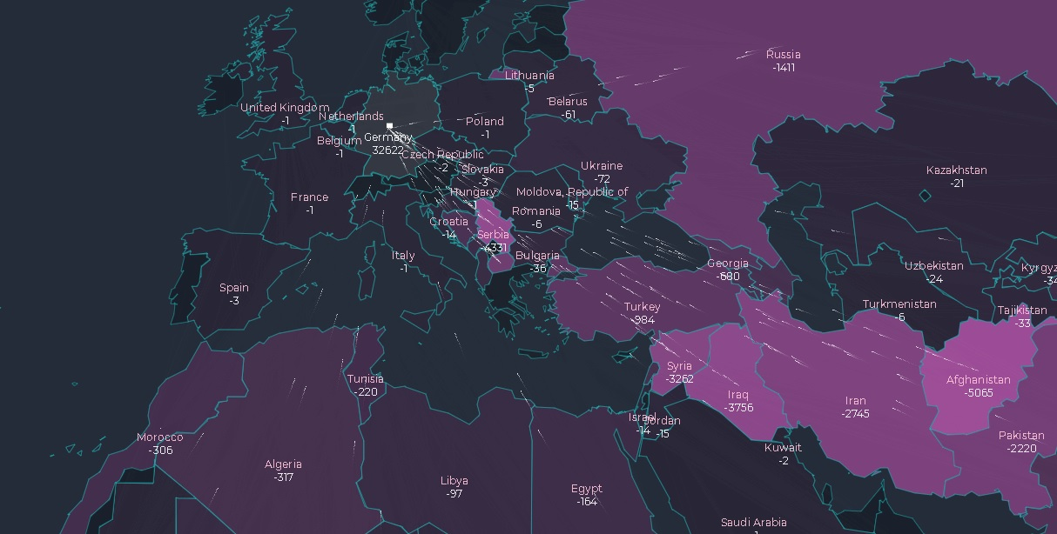

1. **Refugee Demographics**

Link: <http://openmigration.org/en/dashboard/>

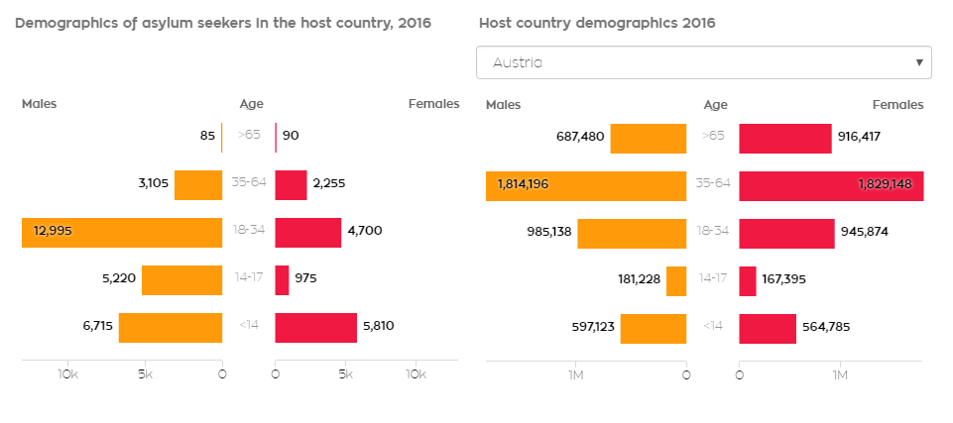

**Code Repository**

Code is hosted on the following github repository

* https://github.com/juzhangdata/Refugee_Project